Odd/Even/Compact* Semester (year)



**BINUS UNIVERSITY**

**BINUS INTERNATIONAL**

**Assignment Cover Letter**

**(Individual/Group* Work****)**

|  |  |  |  |  |  |
| --- | --- | --- | --- | --- | --- |
|  | | | |  |  |
| **Student Information**: **Surname** | | | | **Given Names**  Mika Mahaputra | **Student ID Number**  2301923962 |
|  | | Mika |  |
|  |  |
| **Course Code** | **:Comp6502** |  |  | **Course Name** | **: Progamming Languages** |
| **Class** | **:B2BC** |  |  | **Name of Lecturer(s)** | : 1. Mr Jude Martinez |
|  |  |  |  |  |  |
| **Major** | **:Computer Science** |  |  |  |  |
| **Title of Assignment**  (if any) | **: Shop Project** |  |  |  |  |
| **Type of Assignment**    **Submission Pattern** | **: Project** |  |  |  |  |
| **Due Date** | **: 20-06-20** |  |  | **Submission Date** | **: 20-06-20** |

The assignment should meet the below requirements.

1. Assignment (hard copy) is required to be submitted on clean paper, and (soft copy) as per lecturer’s instructions.
2. Soft copy assignment also requires the signed (hardcopy) submission of this form, which automatically validates the softcopy submission.
3. The above information is complete and legible.
4. Compiled pages are firmly stapled.
5. Assignment has been copied (soft copy and hard copy) for each student ahead of the submission.

# Plagiarism/Cheating

Binus International seriously regards all forms of plagiarism, cheating and collusion as academic offenses which may result in severe penalties, including loss/drop of marks, course/class discontinuity and other possible penalties executed by the university. Please refer to the related course syllabus for further information.

# Declaration of Originality

By signing this assignment, I/we* understand, accept and consent to BiNus International terms and policy on plagiarism. Herewith I/we* declare that the work contained in this assignment is my/our* own work and has not been submitted for the use of assessment in another course or class, except where this has been notified and accepted in advance.

Signature of Student: (Name Of Student)

Mika Mahaputra Mika Mahaputra

Project Report

By: Mika Mahaputra

ID: 2301923962

**Project Specification**

This project is a shop management program that will let the user to manage their item (Price, Name, Quantity and etc). It has some features such as:

* A Menu Option to let users pick their action.
* The usage of libraries.
* Code commenting to make the code more readable.

**Solution Design**

Based on the specification above, this project is to simulate the management of a Shop. For our program we have 3 classes (Main, Shop and Item), each class have its own purpose and unique functions. The item class is used as a constructor and to make getter/setter method. The shop class has many basic functions such as adding items, updating item info, and much more. And finally the main class is used as a driver class.

**UML Diagram**

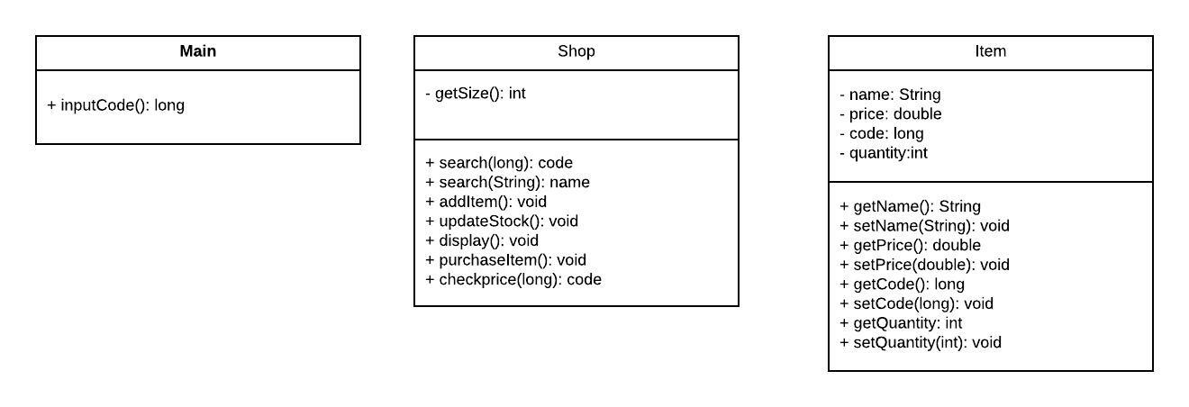

**How The Program Works**

This is the first menu you’ll see when running this program.

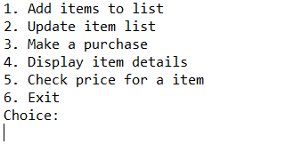

The Item Class has a constructor and all the getter/setter method

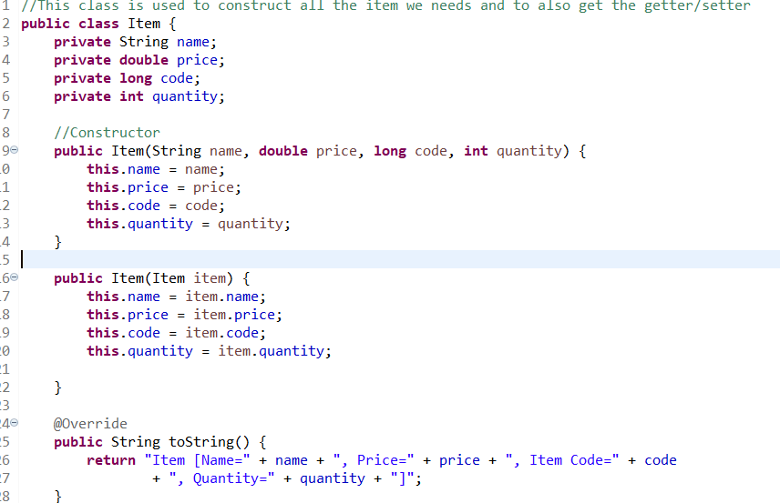

The shop class contains all the functions needed such as Adding a new item, Updating it and etc.

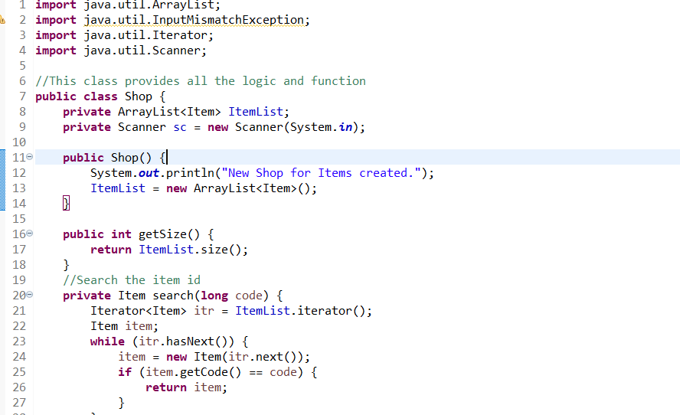

The main class is used as a driver class

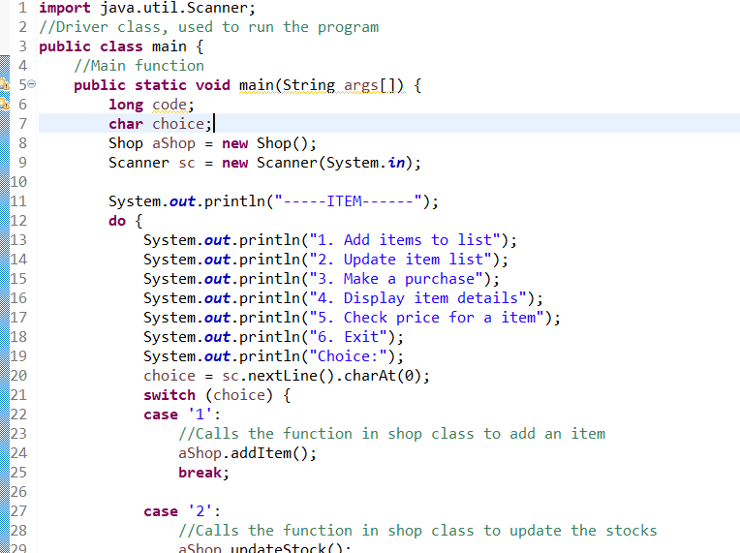

**Conclusion**

So far the Shop Management program works greatly, but it is still far from perfect and has plenty of opportunities for improvements. Doing java projects is fun because it involves OOP and the syntax is pretty easy to use. Although due to many projects and my not so great time management I don’t really have the time to make a more advanced program. Hopefully I will improve my skills on future projects as well as managing my time so I have more time to prepare and to improve, fix and clean my code.